**Cours de Maven et De JPA**

1. **Maven**

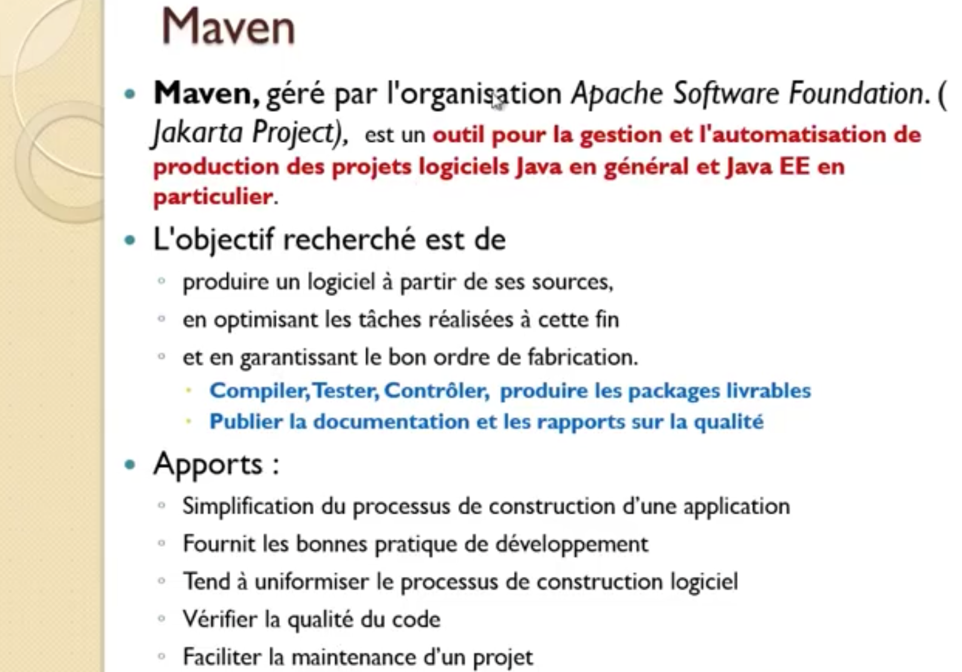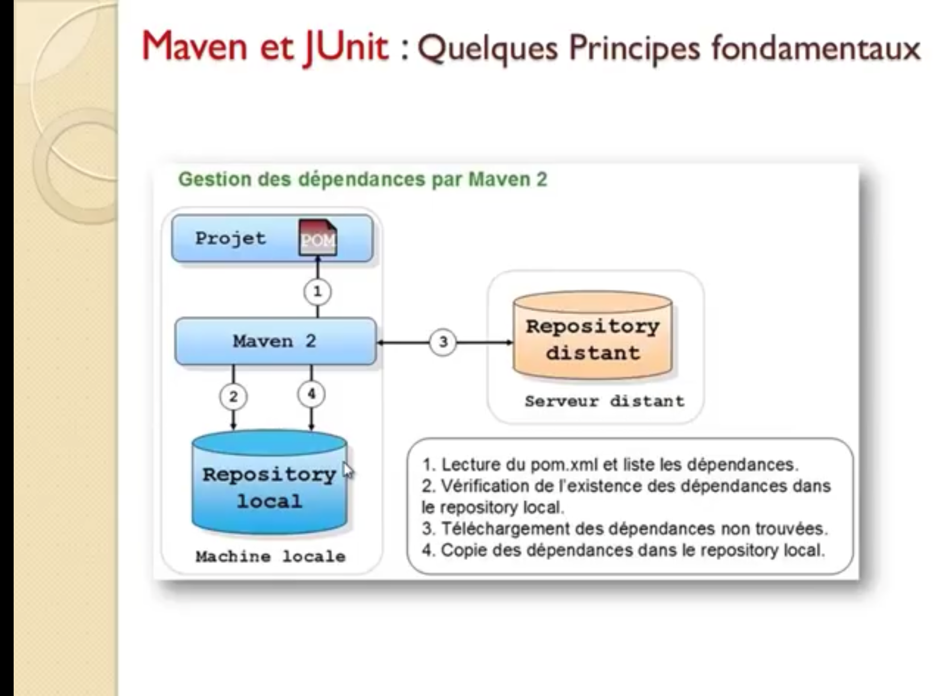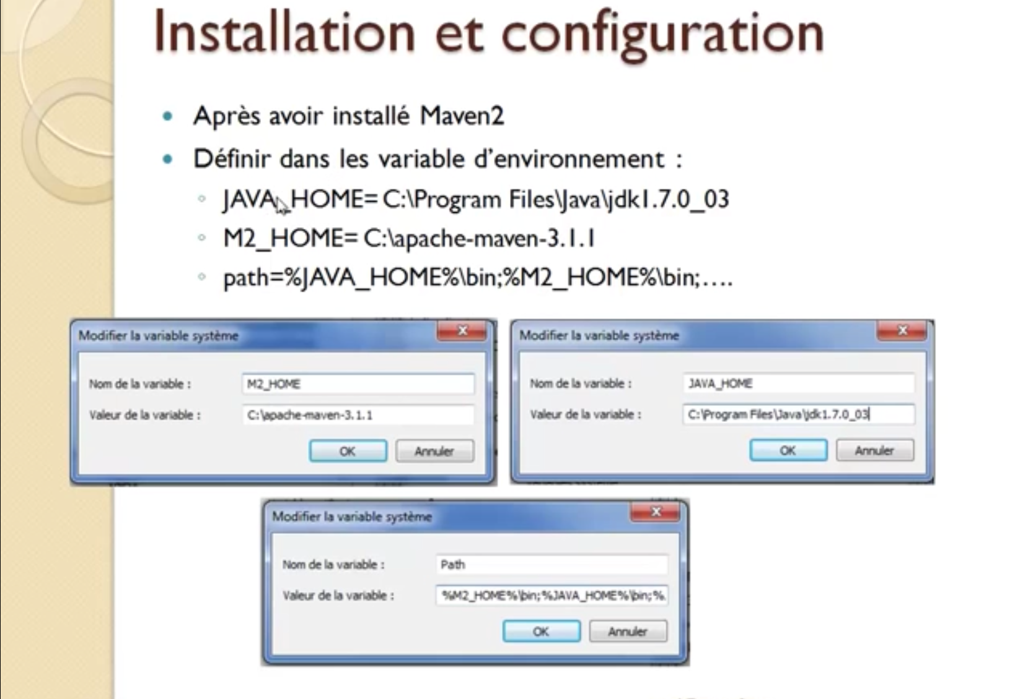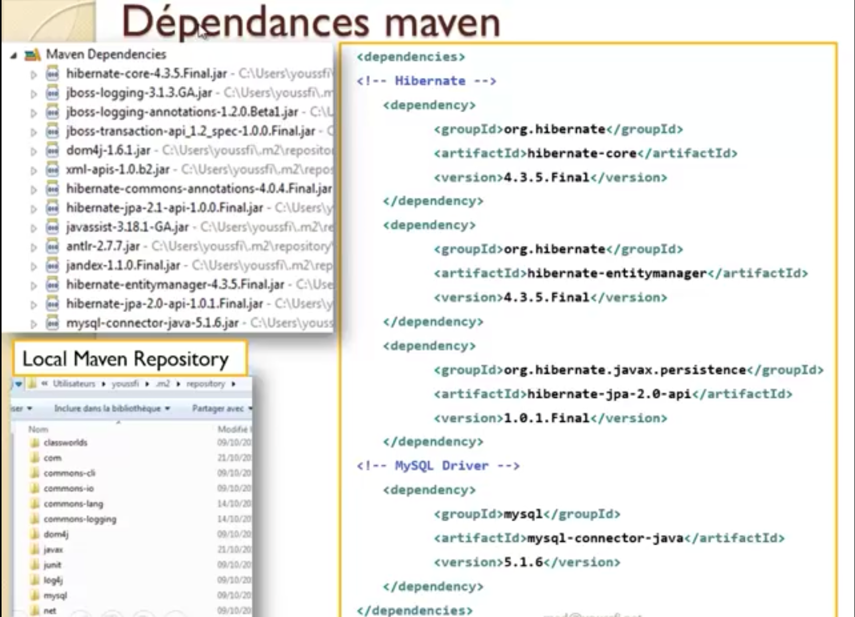

pom.xml

<project xmlns=*"http://maven.apache.org/POM/4.0.0"* xmlns:xsi=*"http://www.w3.org/2001/XMLSchema-instance"* xsi:schemaLocation=*"http://maven.apache.org/POM/4.0.0 http://maven.apache.org/xsd/maven-4.0.0.xsd"*>

<modelVersion>4.0.0</modelVersion>

<groupId>demoFX</groupId>

<artifactId>demoFX</artifactId>

<version>0.0.1-SNAPSHOT</version>

<organization>

<!-- Used as the 'Vendor' for JNLP generation -->

<name>Demon Maven JPA et JAVA FX </name>

</organization>

<dependencies>

<dependency>

<groupId>org.hibernate</groupId>

<artifactId>hibernate-core</artifactId>

<version>4.3.10.Final</version>

</dependency>

<dependency>

<groupId>org.hibernate</groupId>

<artifactId>hibernate-annotations</artifactId>

<version>3.5.6-Final</version>

</dependency>

<dependency>

<groupId>org.hibernate</groupId>

<artifactId>hibernate-entitymanager</artifactId>

<version>4.3.10.Final</version>

</dependency>

<!-- Mysql connector Dependency -->

<dependency>

<groupId>mysql</groupId>

<artifactId>mysql-connector-java</artifactId>

<version>5.1.33</version>

</dependency>

</dependencies>

<build>

<plugins>

<plugin>

<artifactId>maven-compiler-plugin</artifactId>

<version>3.7.0</version>

<configuration>

<source>1.8</source>

<target>1.8</target>

</configuration>

</plugin>

<plugin>

<groupId>com.zenjava</groupId>

<artifactId>javafx-maven-plugin</artifactId>

<version>8.1.2</version>

<configuration>

<mainClass>com.diti4.Main</mainClass>

<nativeInstallers/>

</configuration>

</plugin>

</plugins>

</build>

</project>

1. **JAVA PERSISTANCE API(JPA)**

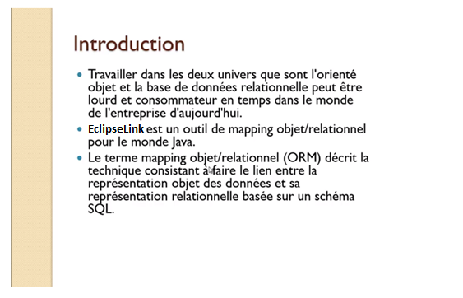

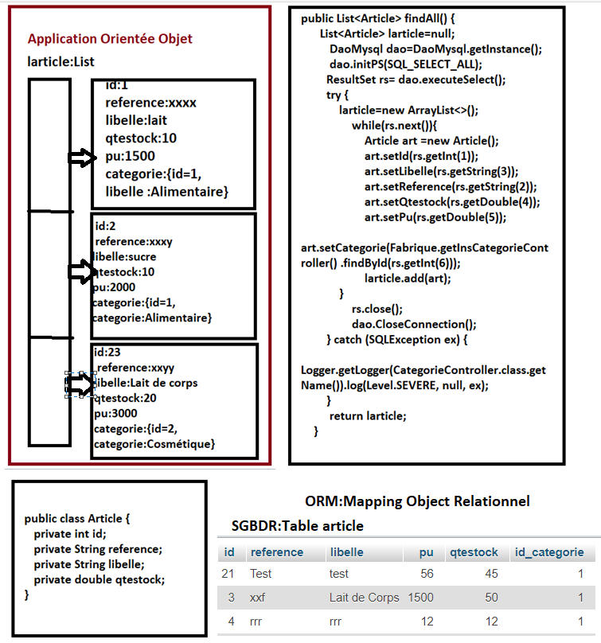

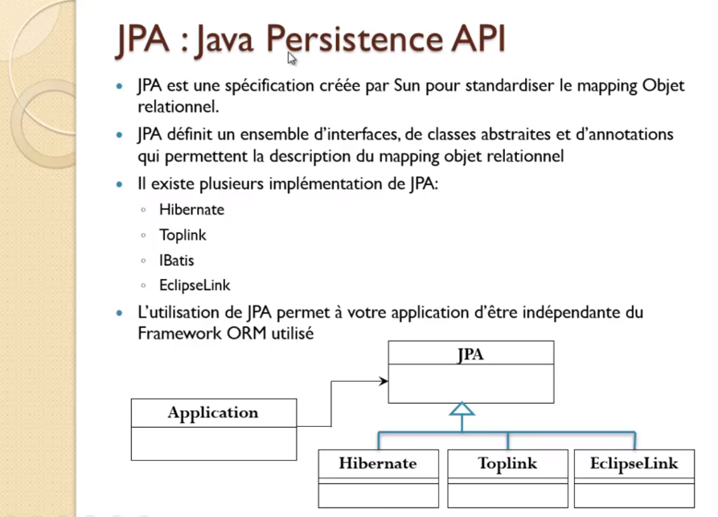

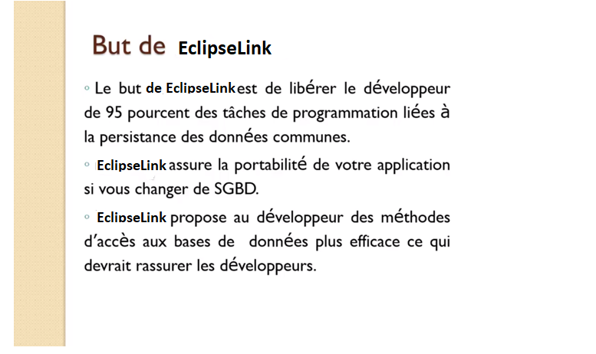

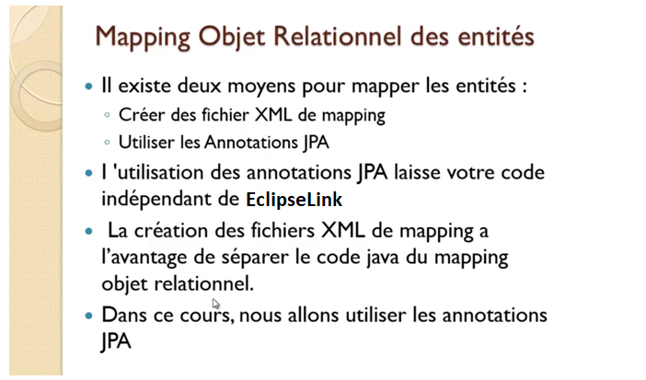

Persistence.xml

<?xml version=*"1.0"* encoding=*"UTF-8"*?>

<persistence version=*"2.1"*

xmlns=*"http://xmlns.jcp.org/xml/ns/persistence"* xmlns:xsi=*"http://www.w3.org/2001/XMLSchema-instance"*

xsi:schemaLocation=*"http://xmlns.jcp.org/xml/ns/persistence http://xmlns.jcp.org/xml/ns/persistence/persistence_2_1.xsd"*>

<persistence-unit name=*"JPADemo"*>

<provider>org.hibernate.ejb.HibernatePersistence</provider>

<properties>

<property name=*"hibernate.archive.autodetection"* value=*"class"* />

<property name=*"hibernate.dialect"* value=*"org.hibernate.dialect.MySQLDialect"* />

<property name=*"hibernate.connection.driver_class"* value=*"com.mysql.jdbc.Driver"* />

<property name=*"hibernate.connection.url"* value=*"jdbc:mysql://localhost:3306/jpadb"* />

<property name=*"hibernate.connection.username"* value=*"root"* />

<property name=*"hibernate.connection.password"* value=*""* />

<!-- <property name="hibernate.show_sql" value="true"/>

<property name="hibernate.flushMode" value="FLUSH_AUTO" />-->

<property name=*"hibernate.hbm2ddl.auto"* value=*"create"* />

</properties>

</persistence-unit>

</persistence>

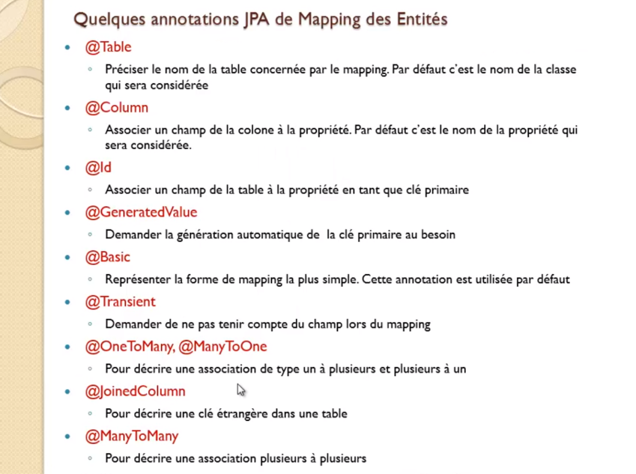

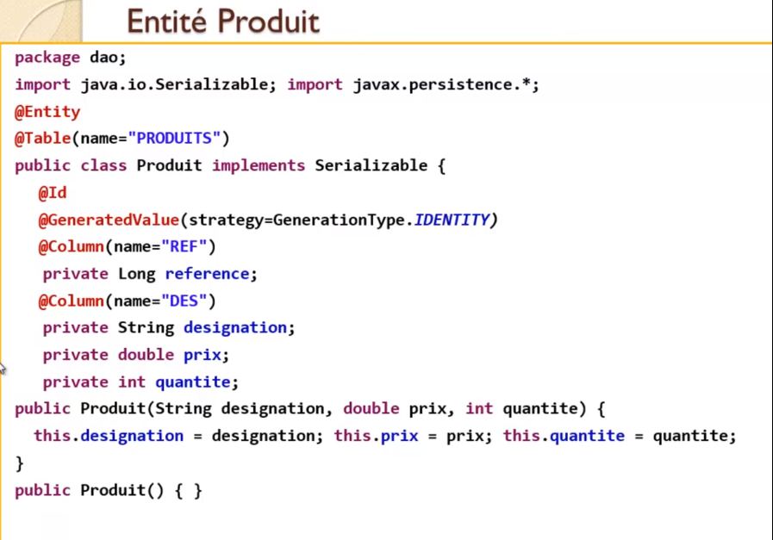

**Relation Entre entité**

**OneToMany**

**ManyToOne**

**ManyToMany**

